**Bug Report for Trello**

1. Create card > User shouldn’t be able to create card on closed board
   1. **Steps :** 
      1. Login to trello
      2. Create board
      3. Close the created board
      4. Try to create card on this board
   2. **Actual :**

While creating the card you will notice that the closed board is selected in board field and if user navigate to board list, he will find it empty

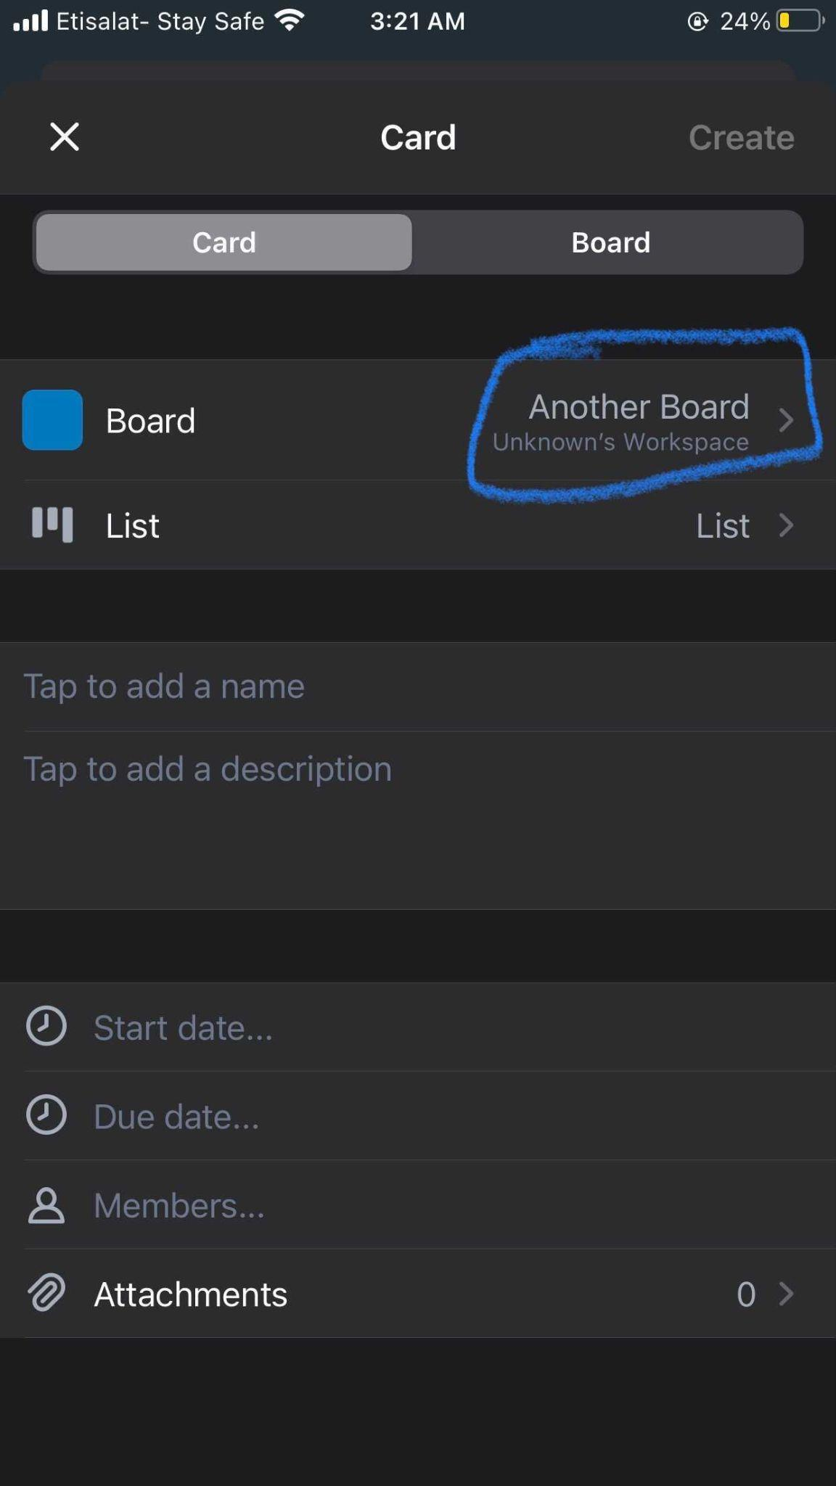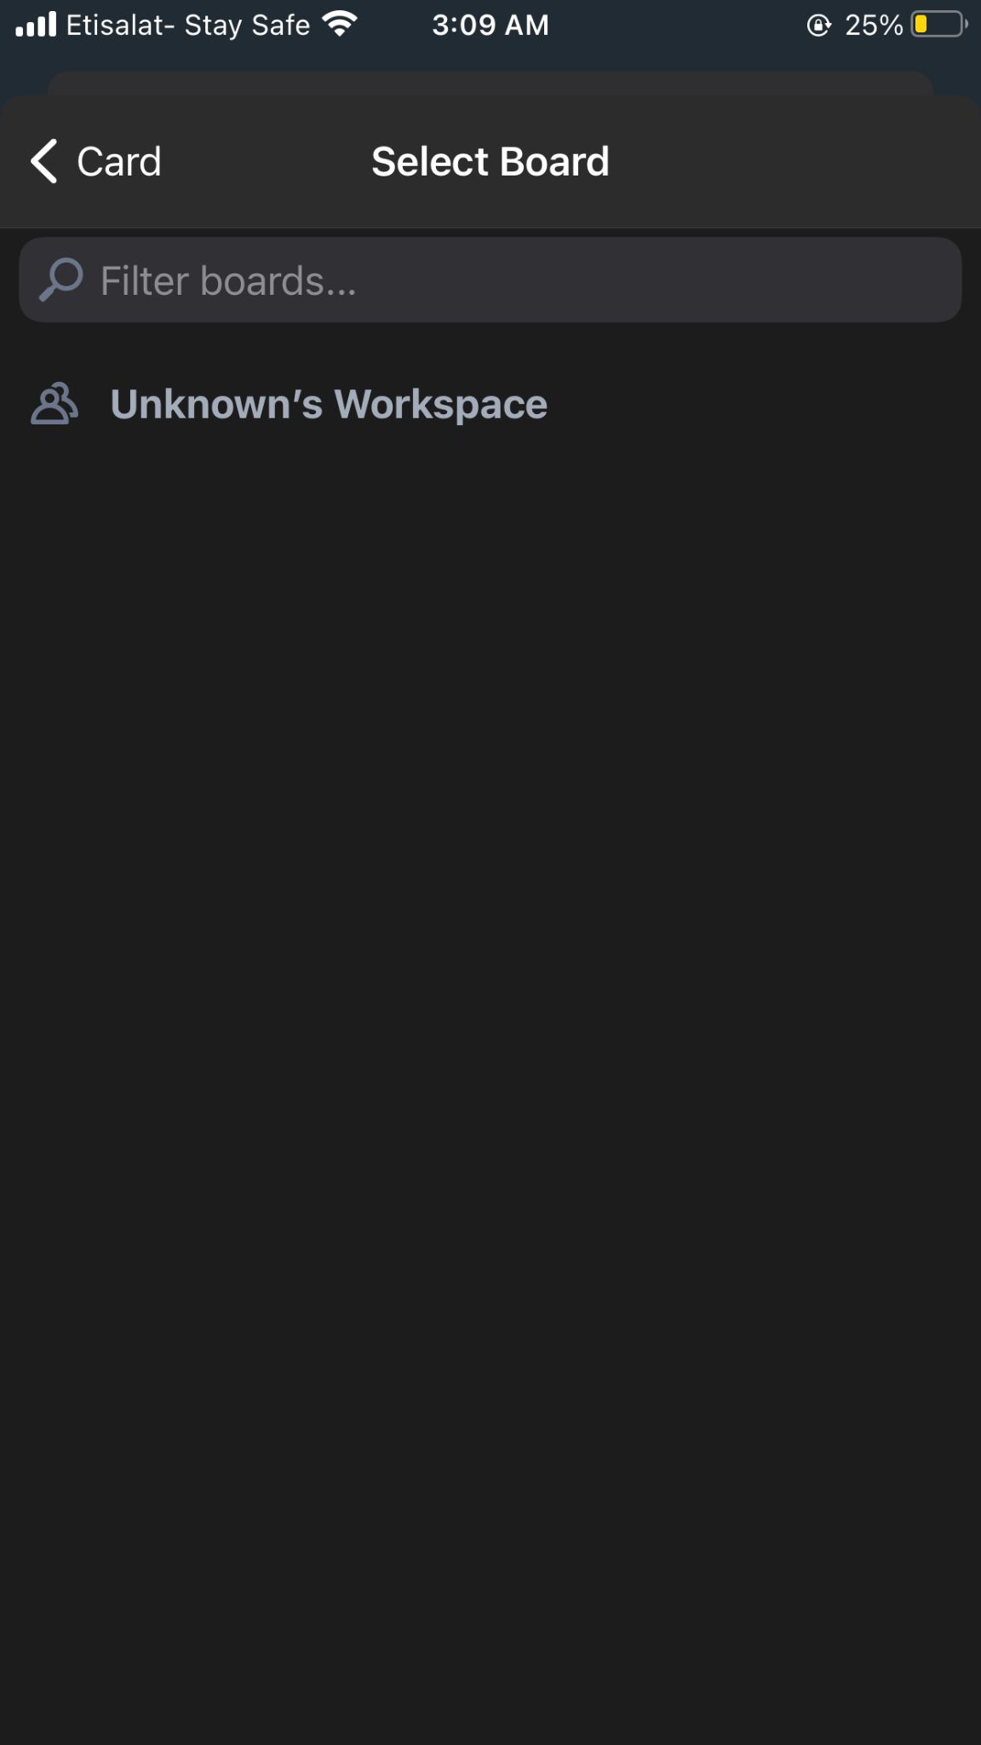

* 1. **Expected :**

The closed card should not be selected in board field and the user shouldn’t be able to create a card on it

* 1. **Affected device :**

iPhone 8 plus

* 1. **Network:**

Wifi

* 1. **Priority :**

1

* 1. **Severity :**

High

1. Create card > User shouldn’t be able to select due date before the start date
   1. **Steps :** 
      1. Login to trello
      2. Create card
      3. Select due date before start date
   2. **Actual :**

The app accepts to select due date before start date

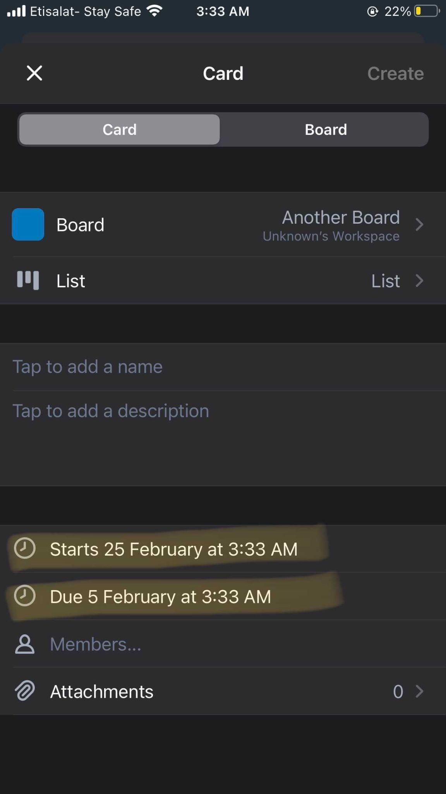

* 1. **Expected :**

User shouldn’t be able to select due date before the start date

* 1. **Affected device :**

iPhone 8 plus, Huawei nova 3i

* 1. **Network:**

Wifi

* 1. **Priority :**

2

* 1. **Severity :**

Medium

1. Create card > Empty Drop down list displayed while creating the card
   1. **Steps :** 
      1. Login to trello
      2. Create card for user doesn’t have board yet
      3. Click board DDL
   2. **Actual :**

An Empty Drop down list displayed while creating the card

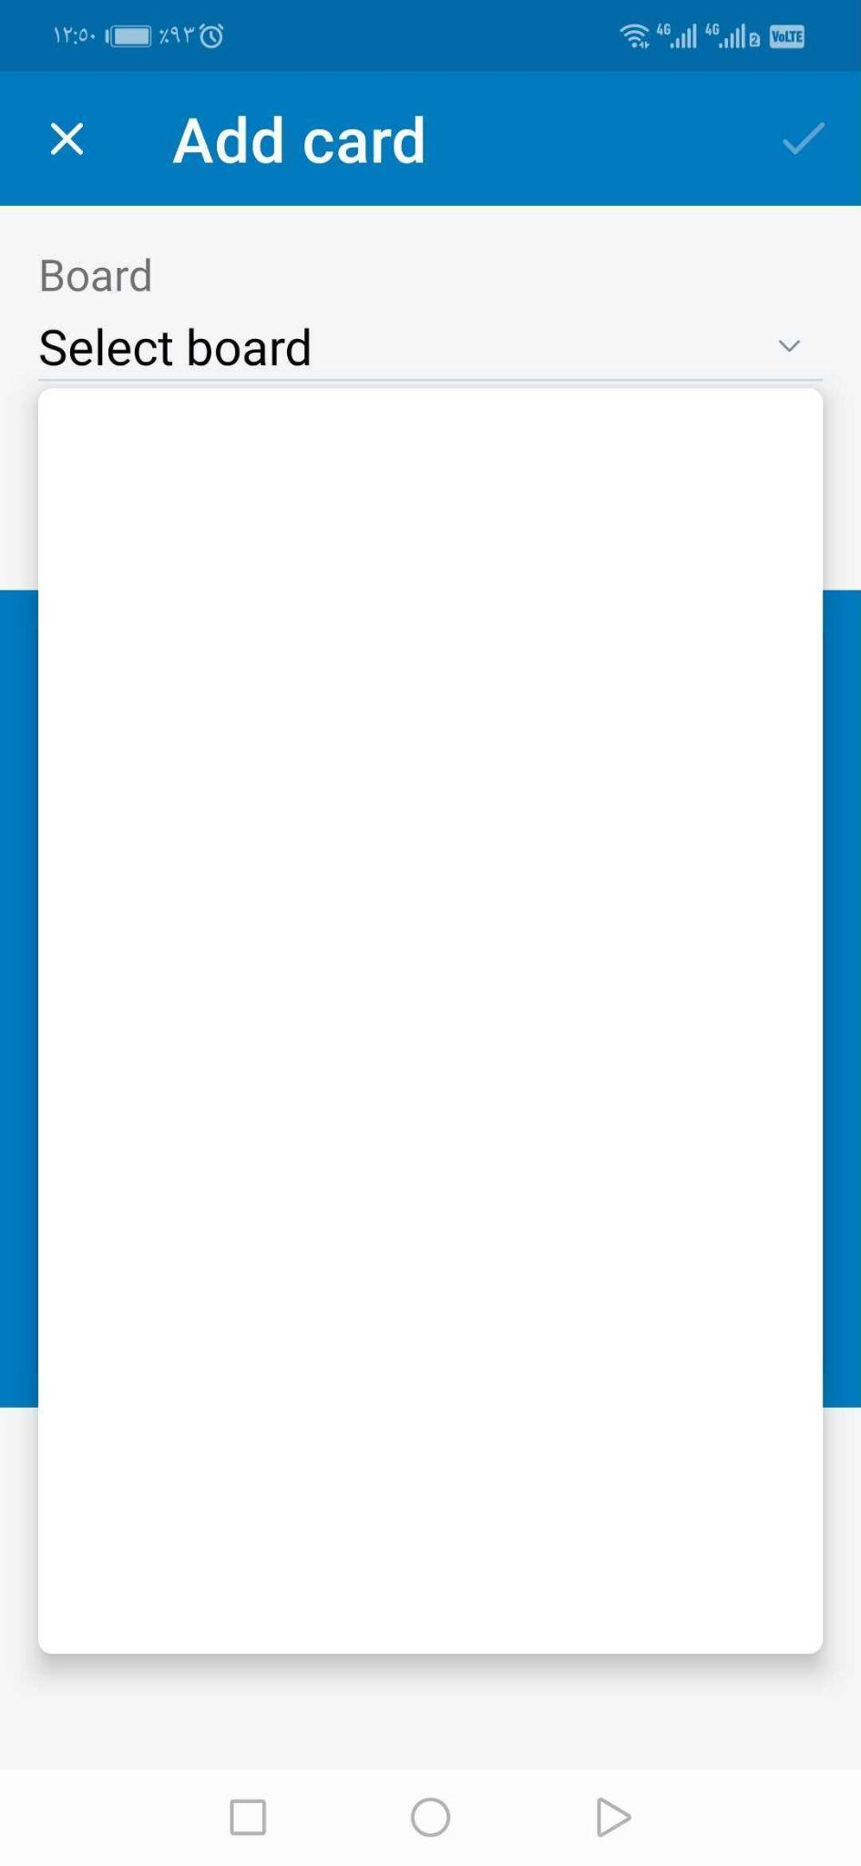

* 1. **Expected :**

Hint should be displayed for the user that he should create board first

* 1. **Affected device :**

iPhone 8 plus, Huawei nova 3i

* 1. **Network:**

Wifi

* 1. **Priority :**

2

* 1. **Severity :**

Low

1. Invite Member > User Avatar overlap the icon
   1. **Steps :** 
      1. Login to trello
      2. Create card
      3. Invite user to this card
      4. Remove this user
      5. Then invite another user
      6. Check the invited users
   2. **Actual :**

After inviting the second user the Avatar of the removed user displayed overlapped on the Avatar of the card owner

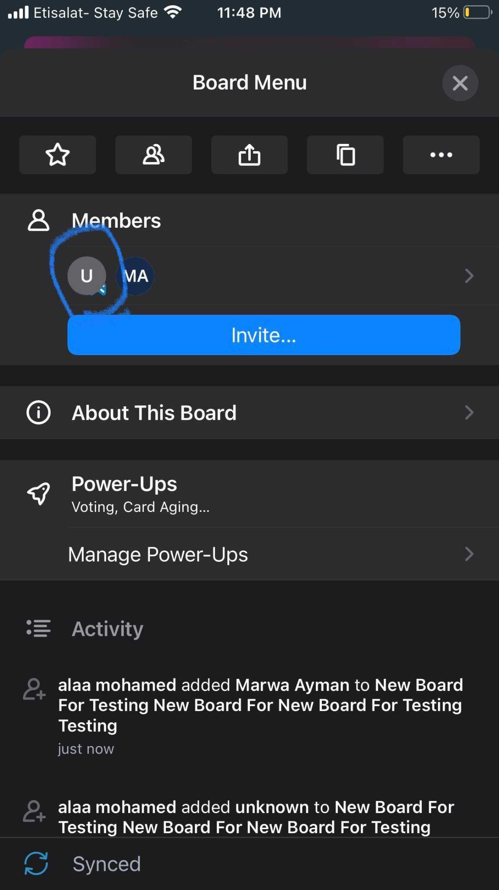

* 1. **Expected :**

The Avatars should be displayed as bellow 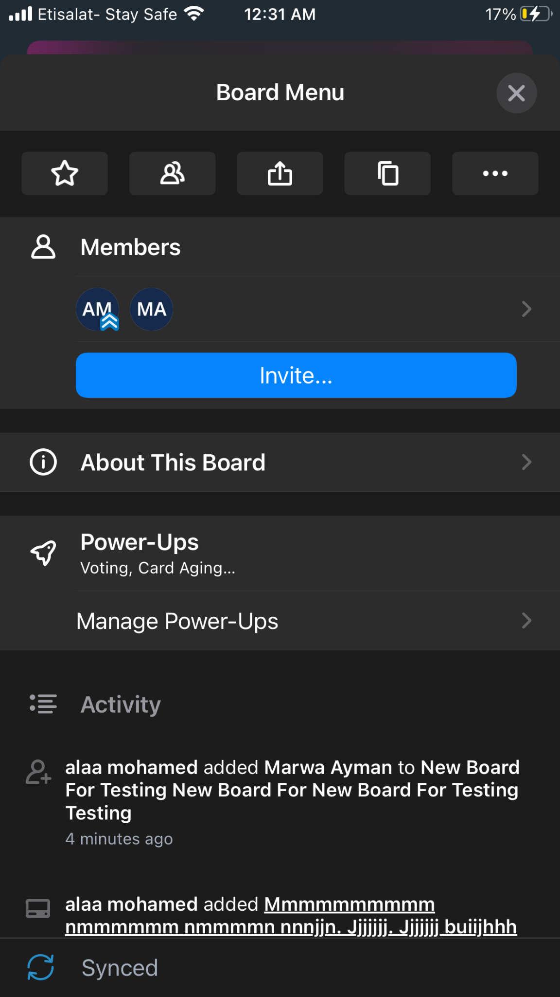

* 1. **Affected device :**

iPhone 8 plus

* 1. **Network:**

Wifi

* 1. **Priority :**

2

* 1. **Severity :**

Medium

1. Board > Favourite icon didn’t appear in the board list until user refresh the page
   1. **Steps :** 
      1. Login to trello
      2. Navigate to any board and mark it as favourite
      3. Check the bard list
   2. **Actual :**

A and B boards are not marked as started although they are displayed in stared board section

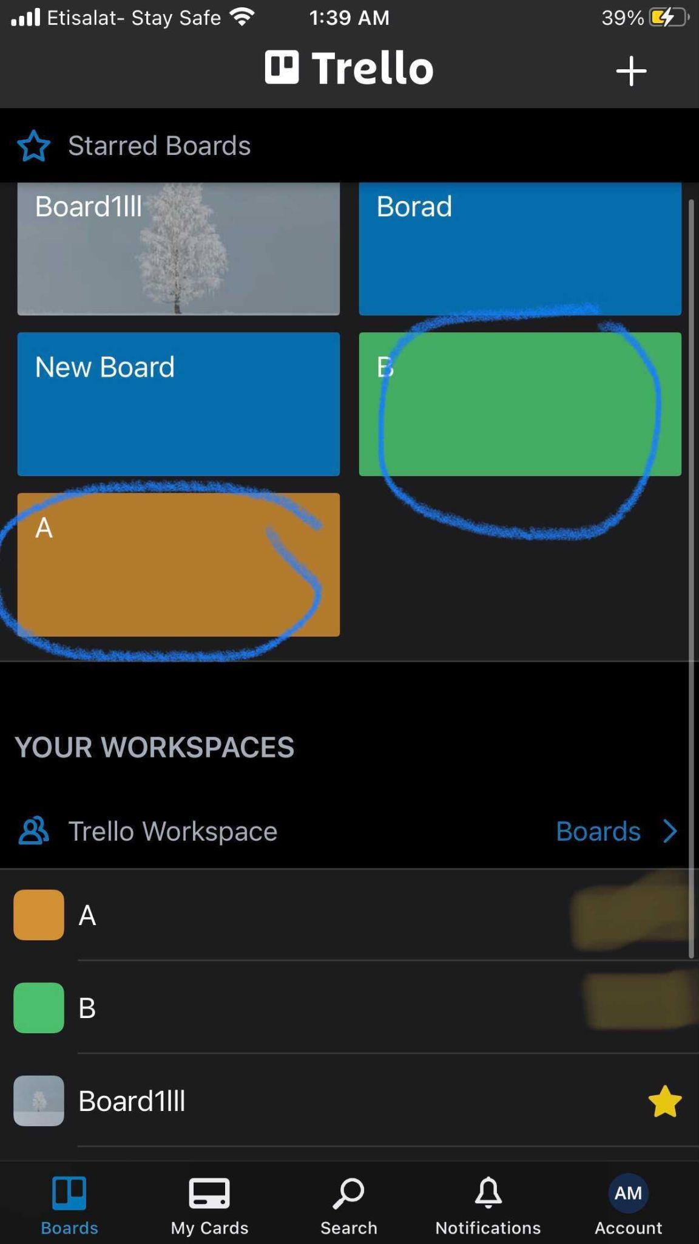

* 1. **Expected :**

No need for refresh to star icon reflect on the list

* 1. **Affected device :**

iPhone 8 plus

* 1. **Network:**

Wifi

* 1. **Priority :**

2

* 1. **Severity :**

Low

1. Notification > Empty state should be applied
   1. **Steps :** 
      1. Login to trello
      2. Navigate to notification page while there isn’t any notification yet
   2. **Actual :**

Empty page is displayed as bellow

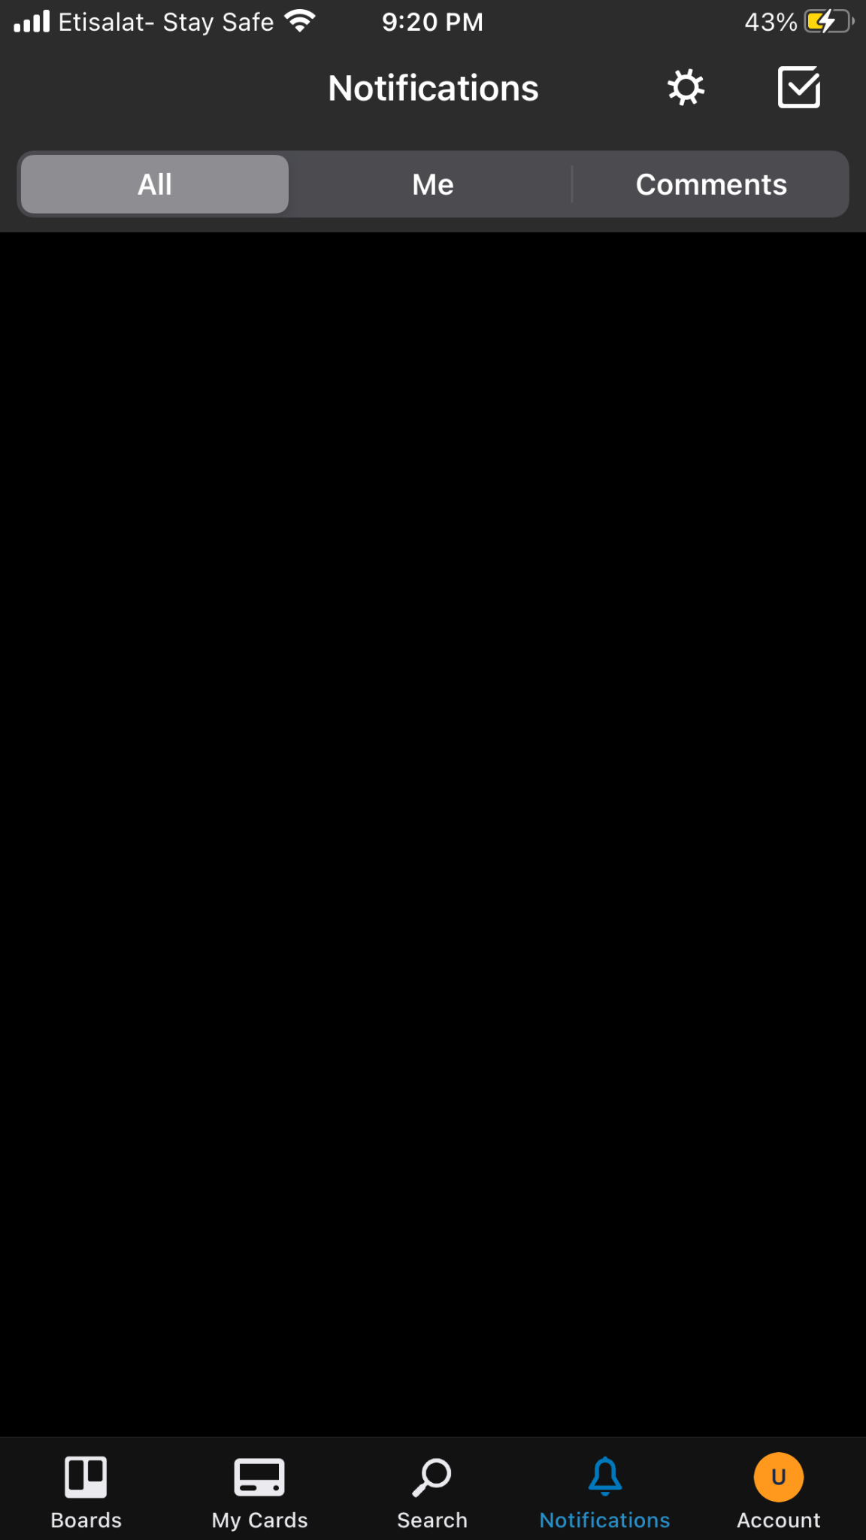

* 1. **Expected :**

Empty state should be applied

* 1. **Affected device :**

iPhone 8 plus

* 1. **Network:**

Wifi

* 1. **Priority :**

3

* 1. **Severity :**

low